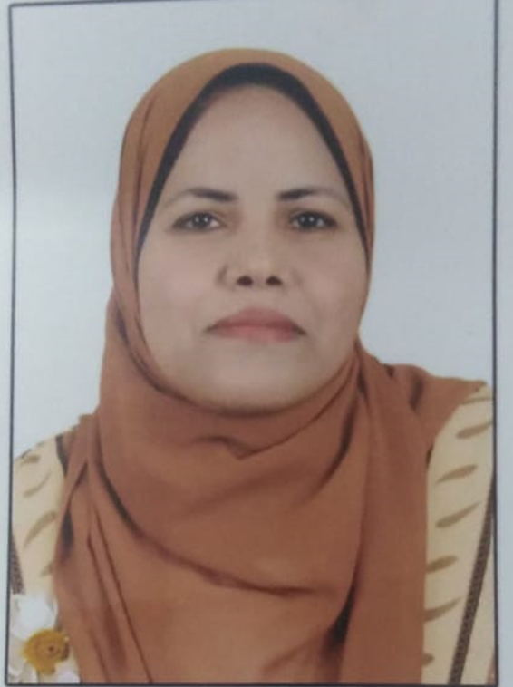 C.V.
السيرة الذاتيه
First:-General information:-
Name: Reda Refae Ali Abdel wahed
Current Position:- Assistant professor of obstetrics and Gynecological NURSING
DATE of Birth:- 1/12/1983
Marital status: Married
Address: New Assiut - Almostakbal residence.
Mobile No.: (01016532050)
E-mail: Areda48@yahoo.com Areda2010@gmail.com drredaali@aun.edu.eg

Second: Academic Qualifications:

University / college | Year of obtaining the degree | Academic degree
Assiut University - Faculty of Nursing | 2016 | 1- Ph.D
Assiut University - Faculty of Nursing | 2012 | . 2- Master's degree
Assiut University - Faculty of Nursing | 2005 | 3- Bachelor's degree / BA

Third: Academic career progression (internal and external):

organization name | year of joining, | Position
South Valley University - Qena - Faculty of Nursing | 2007 | Teaching assistant at the Department of Obstetrics and Gynecology
South Valley University - Qena - Faculty of Nursing | 2012 | Assistant Lecturer, Department of Obstetrics and Gynecology,
South Valley University - Qena - Faculty of Nursing | 2016 | Lecturer, Department of Obstetrics and Gynecology,
Assuit university –faculty of nursing | 2022 | Assistant professor of Obstetrics and GynecologyNursing
Fourth: Training courses in the field of quality management systems:
1- Quality management program in the educational process.
2- Institutional self-evaluation session for higher education institutions.
3- External review session for higher education institutions.
4- Credit Hours Program.
5- Conference management program.
6- Training course on how to be a successful coach.
7- Attending a training course on (intercultural communication).
8- The strategic planning program.
9- Using the global databases in Qena in cooperation with the Supreme Council of Universities.
10- Competitive Research Program
Fifth: Various activities in the field of quality management systems:
Locally: none
Regionally (if any):
There is no
Globally (if any):
There is no
Sixth: Various other activities related to the educational process and community service
1- Participation in the first scientific conference of the Faculty of Nursing at Assiut University (Nursing and Community Service).
2- Giving some courses related to hospital infection and how to control infection and health education for women.
3- Currently working on the stereoscopic project for the Department of Obstetrics and Gynecology at the college

- the first international nursing conference entitled" Nursing and current challenges".
- Medical Emergencies ,Assuit University
- Database program
- Statistical Analysis using SPSS programm.
- Presentation program.
- Advanced techonology and patient centered care conference in tanta university.
- Nursig in upper Egypt between the reality and expectations in sohage university.
- Pediatric urology sector of Egyptian urological Association "assuit unversity"
- Conference of gastroenterology and liver diseases. In assuit university.
- Workshop in training course on the field of descriptive and applied statistics for nursing researches.
- Workshop on intercultural understanding.
- Level one of assuit university English language centre programme.
- Scientific conference of faculty of nursing Assuit university "Nursing and community health".
- ENSSA training development Division
- Work shop about the new in infertility at Assuit university.
- Scientific conference of faculty of nursing,obstetrics &Gynecological Nursing Departement at Assuit university "New in Obstetrics and Gynecological Research".
- Work shop about research methodology in faculty of nursing at south valley university.
- Coordinator of the first scientific day of obstetrics and Gynecology department at qena university (updates in obstetrics and Gynecological nursing)
- Attendance in 4th scientific day for faculty of nursing sohage university.
- Scientific conference of faculty of medical emergencies 19th -20th march 2015,assuit.
- Attendance the first international nursing international entiteled(nursing and current challenges) at Minia university on April 2010 .
- Participation in training course on the field of descriptive and applied statistics for nursing researchers on 22nd march 2010.
- Attendance (Enssa training development division) program agust 8th .9th ,10th 2013.
- Attendance the 1st scientific conference of faculty of nursing (Nursing and Community Health).
- Attendenace and active participation in the activities of the third undergraduate student scientific conference (new technologies in nursing sciences) Saturday 31 jan.2017,faculty of nursing –assuit university.
- مشرف كلية التمريض جنوب الوادى فى فعاليات الملتقى القمى الثانى لطلاب كليات التمريض بالجامعات المصرية تحت شعار (بلدنا تجمعنا) من 29 يناير حتى 2فبراير 2017.
- ندوة توعوية عن كيفية الكشف المبكر عن سرطان الثدى لسيدات جراجوس مركز قوص محافظة قنا وذلك 29-10-2016.
- المشاركة الفعالة فى ورشة العمل المشتركة بين كلية التمريض جامعة جنوب الوادى وتمريض مستشفى هنجلو الهولاندية بعنوان الرعاية التمريضية للحالات الطارئة.
- Advanced powerpoint course
- المشاركة فى انجاز اليوم التمريضى الاول لكليات جامعة جنوب الوادى
- Participation In (International Nurses Day Celebration) of faculty of nursing –south valley university (Nursing Acontinuous And Holistic Care)
- Attendance the 1st scientific conference of critical care medicine unit assuit university in collaboration with kasr al ainy ,cairo university2015.

